FIT4039

Android and iOS development

Assignment1

Mobile Application Design Specification

Name: Shen Yang

Student ID: 28156137

Date: 28/03/2018

Table of Contents

1. Application Concept 1

1.1 Introduction 1

1.2 Key Functionalities 1

1.2 Target audience 3

2. Idea Innovation 3

3. Platform Technology Considerations 3

3.1 Android Technology Considerations 3

3.2 iOS Technology Considerations 4

4. Interface Design Storyboard Mock-ups 4

5. Scope and Limitations 27

6. Project Timeline 27

7. Competitive Analysis 32

7.1 SWOT Analysis 32

7.2 App Store Analysis 38

7.3 Target Audience ‘Needs’ Analysis 39

8. References 40

# 1. Application Concept

## 1.1 Introduction

This app going to be code is a running app combining with some game elements to record the users’ daily workouts and allow users to share their moments with their friends using this app.

The purpose of this app is to appeal for a healthy life and attract more users to do workouts daily to keep fit.

Some people may be unwilling to do workouts every day, thus the adding of the game elements would encourage them to do workouts daily.

## 1.2 Key Functionalities

**Login Screen:**

1. Login screen with pixel style background.

2. Forget password function.

3. Create new account function.

**Home Screen:**

4. Record daily activities and display the data on the home screen.

5. Track users’ recent workout records and allow users to see the detail history records.

6. A START WORKOUT button is used to start a new workout.

7. Home screen pixel picture will change according to the users’ miles.

**Start Workout Screen:**

8. Map showing the current position would used as the background while users start a workout.

9. While running, the duration, miles, calories would change dynamically.

10. End workout button would end the recording.

**History Screen:**

11. History record screen will show all the workout records with date, miles, pace and steps.

**Report Screen:**

12. Weekly or monthly diagram would be generated according to the data.

13. Users can swap left or right to change the data of calories and steps.

**Friends Screen:**

14. Users can post new message on the app.

15. Users can see other people’s posts and make comments on them.

**Setting Screen:**

16. Users can change their profile photo.

17. Users can change their password.

18. Users can choose whether to save their login information or not.

19. Users can choose to use their pixel character as their profile photo. Once switched on the button, application would create a pixel photo for them.

20. Users can change the application language.

21. Automatic notification can be switched off.

22. Log out can be achieved through the button.

**Me Screen:**

23. Likes button would list all current user’s shared moments which are liked by other users.

24. Friends button would list all current user’s friends.

25. Comments button would list all current user’s shared moments which are commented by other users.

26. Articles can be pushed by the application to users.

27. Pushed contents can be cleared from the screen.

**My Friends Screen:**

28. All friends are sorted and ordered alphabetically.

29. Quick guide letters are provided aside.

**Add Friends Screen:**

30. Search bar is provided to do the vague search or accurate search operation.

31. Once user enter some value into the search bar, matched results would appear below.

32. Add button is provided to add the user.

**Store Screen:**

33. Application would generate a pixel character for each user, the default character would appear on the store screen.

34. Buyable costumes would be supplied below to allow users decorate their characters.

**Ranking Screen:**

35. All the daily data of friends of the current users would be listed and ranked.

36. Application would generate a pixel style picture for the top 3 users. The looking of the character would change according to what they buy in the store.

**User Profile Screen:**

37. User detail information, their pixel character and their past posts would be listed here.

## 1.2 Target audience

The target audiences are those who always do the workouts and the game elements adding to this app aims to attract users who prefer playing mobile games and female users who prefer playing the dressing up games.

For those tradition fitness app users, this app provides them with the same functionalities as other running app in the app store provide. Moreover, this app utilizes a simple and tidy layout to display data which would bring users a purer experience.

A tough issue for the users using fitness apps is they may easily forget to open or subjectively refuse to open such kind of applications. Workouts can be a hard mission to some people. To solve such problem, the dressing up function is designed to build the sticky customer relationships to hold users meanwhile attract more new users. Moreover, the ranking system combining with the dressing up system would encourage users to do workouts more frequently to gain more e-corns to buy the costumes.

# 2. Idea Innovation

In contrast with other fitness applications available on the market, this application is unique not only because its clean layout but also its conception. Combined with the dressing up idea which will absolutely make this app to be a both practical and interesting application.

* The clear navigation would guide users to easily approach what they want.
* Social features added would improve stickiness by allowing users to build a relationship with friends over a long period of time. Users can do more things rather than close the app after workouts.
* The diagrams generated by the application are clean but cover all the essential information, which will response to users’ requirements accurately and quickly.
* Unlike other apps requiring users to set an invisible goal., the dressing up game future added will provide users a clearer goal to do workouts, that is to exchange e-corn with their steps to buy specific costumes.

# 3. Platform Technology Considerations

## 3.1 Android Technology Considerations

* SQLite database should be built to store user registration information.
* Firebase database should be used to store user records and other messages.
* Firebase authentication should be used to assist users to login from other federated identity providers.
* Firebase notification composer will be added to send daily message or notifications to all the users.
* GPS sensor or location sensor will be used to record the running.
* Use fragments to display dynamic picture.
* Use GifImageView to display .gif pictures.
* Use AndriodSwipeLayout to achieve delete friends function.

## 3.2 iOS Technology Considerations

* Core Data database should be built to store user registration information.
* Firebase database should be used to store user records and other messages.
* Firebase authentication should be used to assist users to login from other federated identity providers.
* Firebase notification composer will be added to send daily message or notifications to all the users.
* Use locationManager and CLLocationManager to record running and draw the maps.
* Use spritekit to generate dynamic animations.
* RKDropdownAlert would use to set notification to users.
* JVFloatLabeledTextField would be used to customize user input textarea.

# 4. Interface Design Storyboard Mock-ups

**From login screen to create account screen:**

On the screen, there would be several text input areas to allow users to input data. The use of colour strictly obeys the colour design guideline ‘Ensure sufficient contrast’.

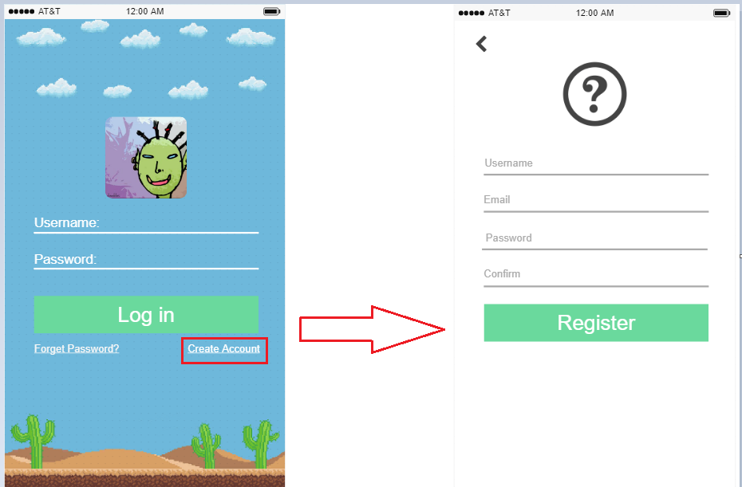

Interface for iOS

As for the login page, there would be no difference between two platforms.

**From Login to Home screen:**

In iOS interface, according to iOS design guideline, tab bar should be used to present peer categories. Also, according to the navigation guideline, interface should provide user with good navigation cues. Thus, the big button and icons with strong metaphors are used in the home screen.

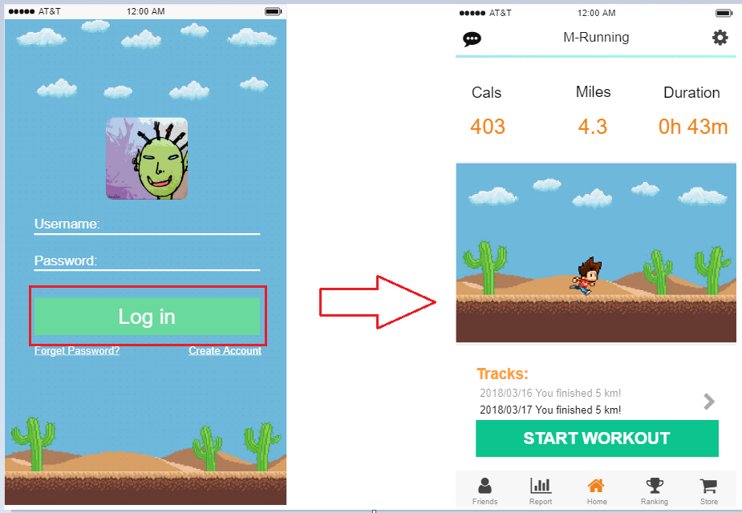

Interface for iOS

Differently in android, android does not use tab bar to present peer categories, thus tab menu at the top is introduced to present peer categories.

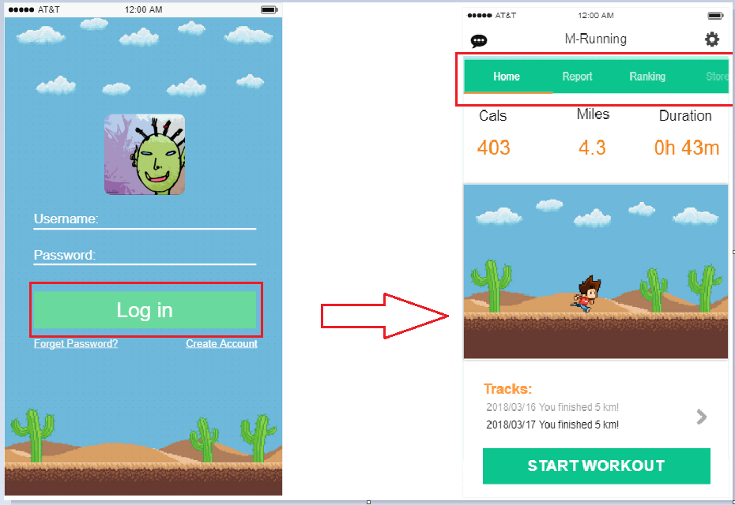

Interface for Android

**From Home to Start workout screen:**

The workout screen design obeys the iOS design guideline of ‘Provide a fast and easy way to get to the content’. No matter the data display or the button display, they are designed pretty easy and clear.

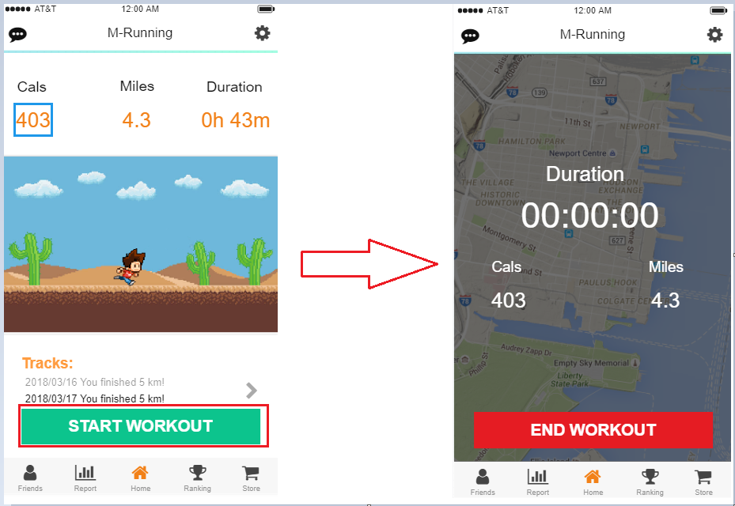

Interface for iOS

In terms of android, the design concept is the same with iOS except the return function. Android devices have virtual buttons to enable users go back to the previous page, thus no return button is designed here.

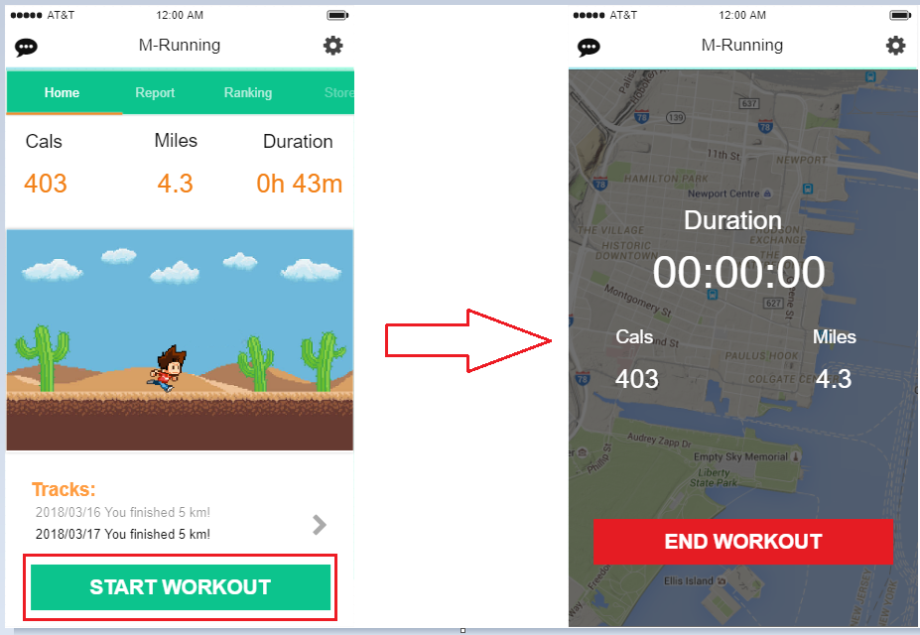

Interface for Android

**From Home state1 to Home state2:**

As an important element implemented in this app, the pixel picture will change according to the users’ fitness data and character information.

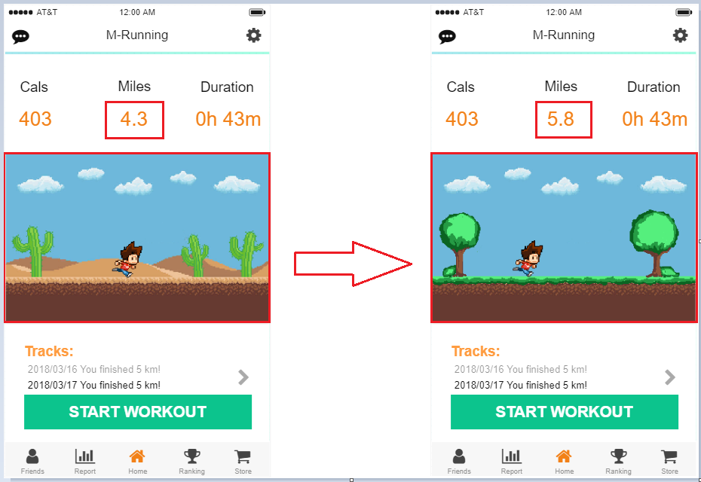

Interface for iOS

The interface for Android would be the same as demonstrated before.

**From Home to History screen:**

To enable users to get their content fast and accurate, the design of history screen is also simple and clear.

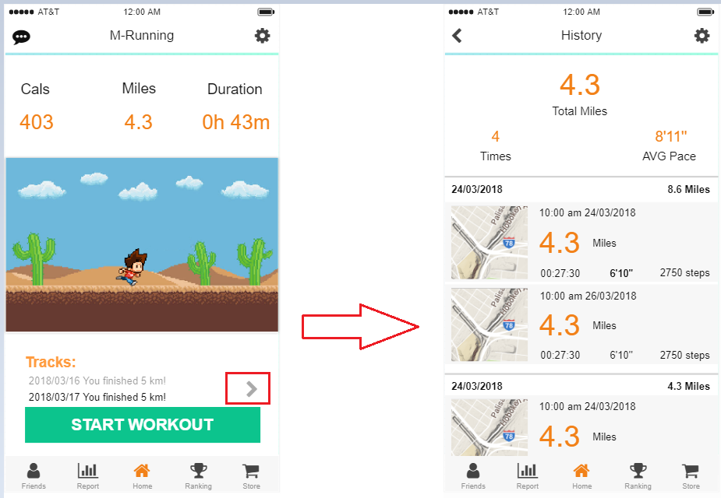

Interface for iOS

Android is quite the same except the tab bar.

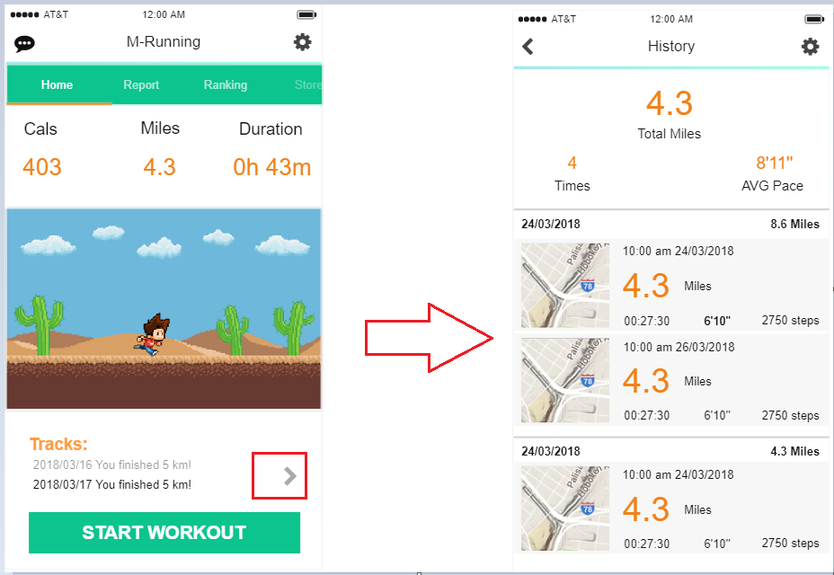

Interface for Android

**From Home to Report Screen:**

The swap of categories is achieved by taping the tab bar.

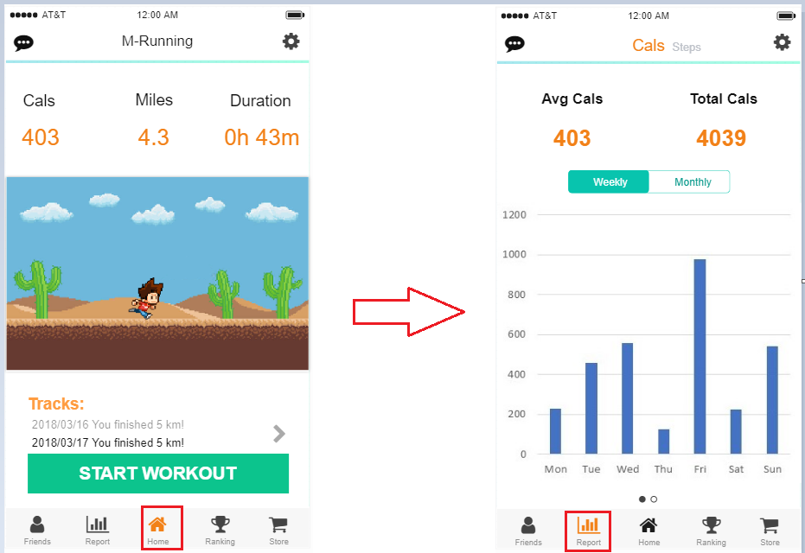

Interface for iOS

For android, the page changing can be achieved by swapping left or right or tab the tab menu at the top.

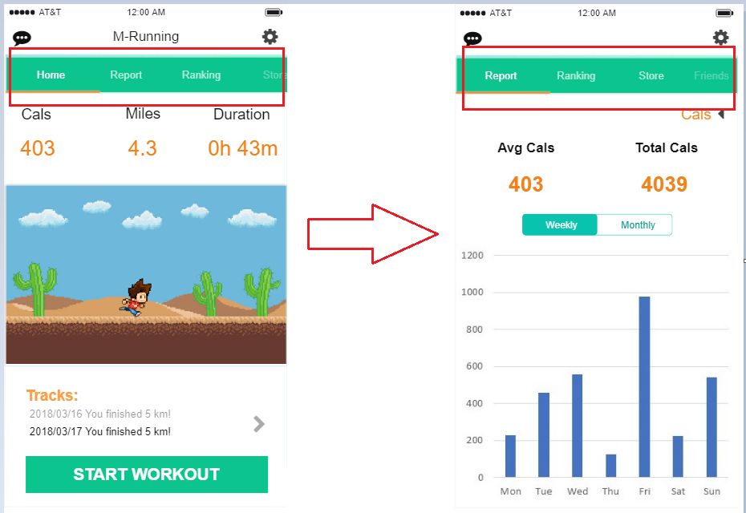

Interface for Android

**Inside Report Screen:**

With iOS, to change the weekly report to monthly report, segmented control is used to achieve that or just swap left or right on the chart diagram, which obeys the iOS design guideline of ‘Use touch gestures to create fluidity’ and ‘Use a page control for multiple peer pages’.

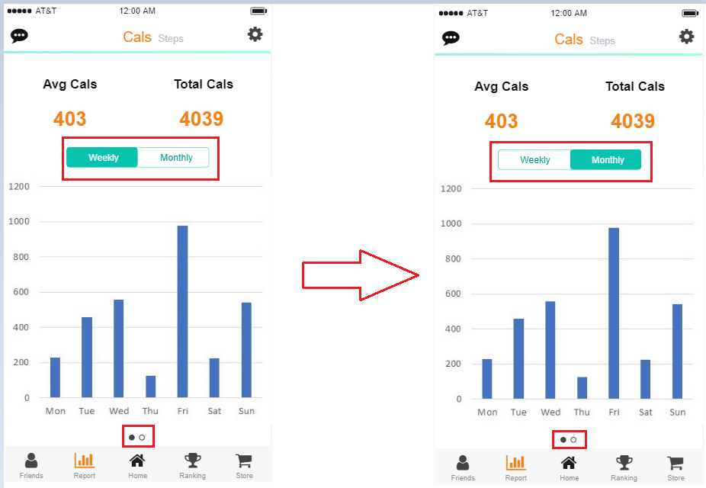

Interface for iOS

Familiarly, to swap from Cals to Steps, just swap the whole page would easily achieve it in iOS.

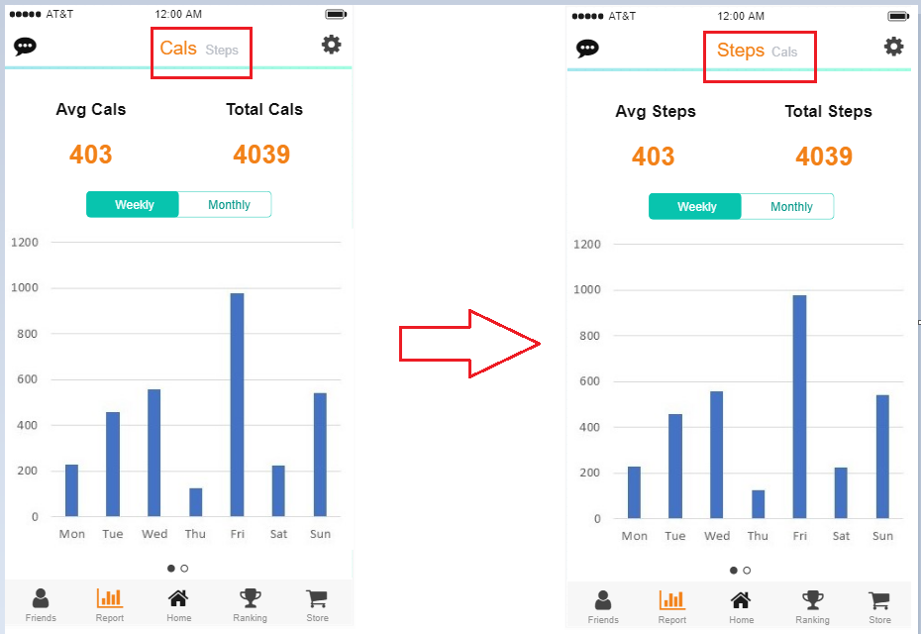

Interface for iOS

In terms of Android, the swap from weekly to monthly is quite the same as in iOS.

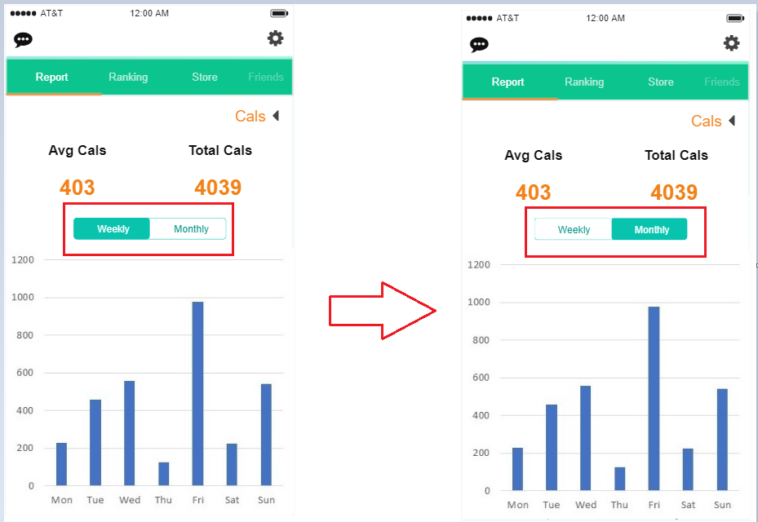

Interface for Android

However, the swap from Cals to Steps is different because the tab menu has been used to present root categories. Thus, we use some icon to achieve the operation.

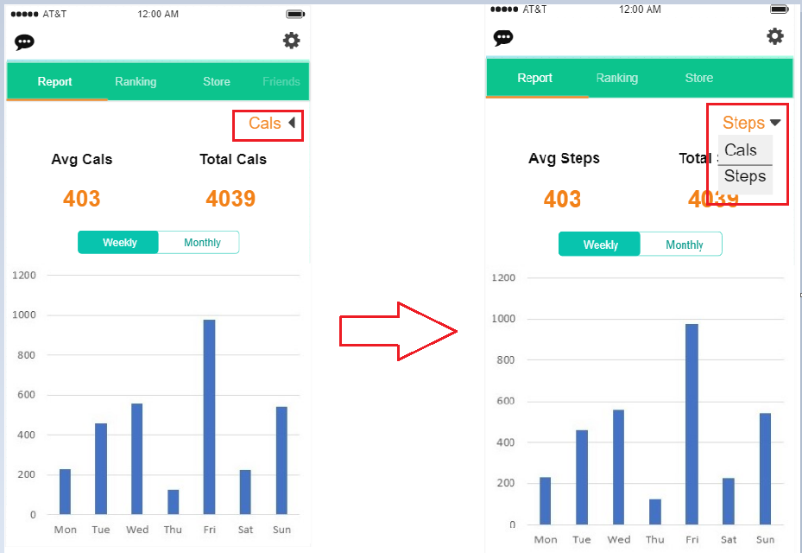

Interface for Android

**From Home to Friends:**

The swap of categories is achieved by taping the tab bar.

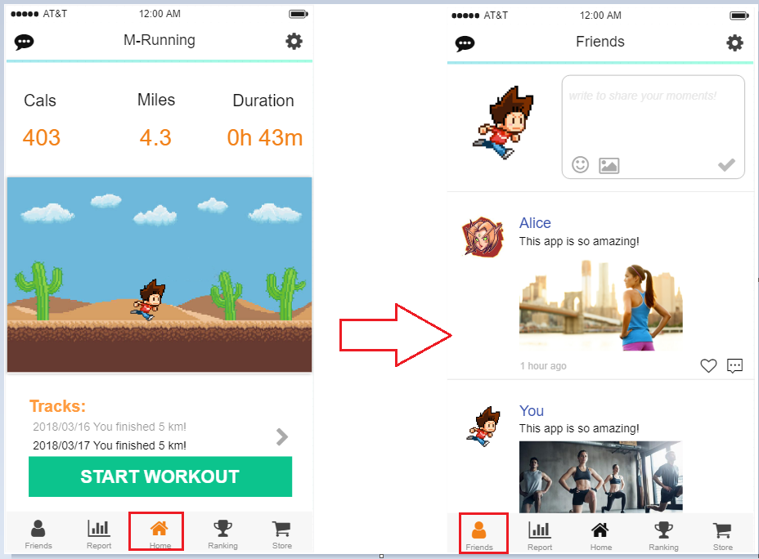

Interface for iOS

For android, the page changing can be achieved by swapping left or right or tab the tab menu at the top.

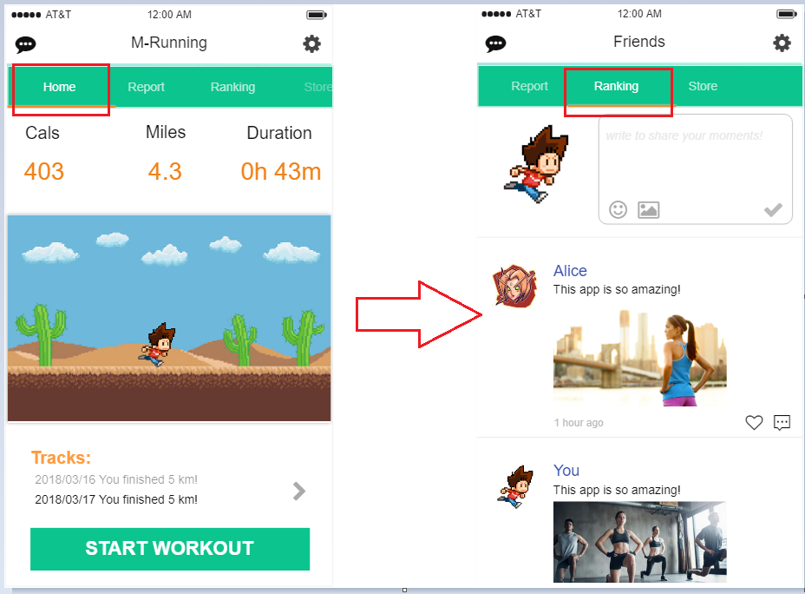

Interface for Android

**Inside Friends page:**

According to iOS design guideline ‘Use standard navigation components’ and the icons guideline of ‘icons are based on metaphors’, the use of components and icons in this application strictly obey these two guidelines.

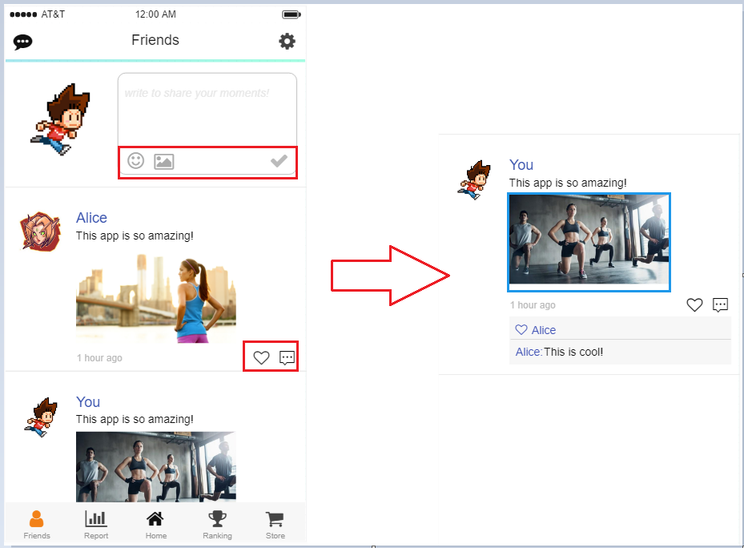

Interface for iOS

The design guidelines are same in Android.

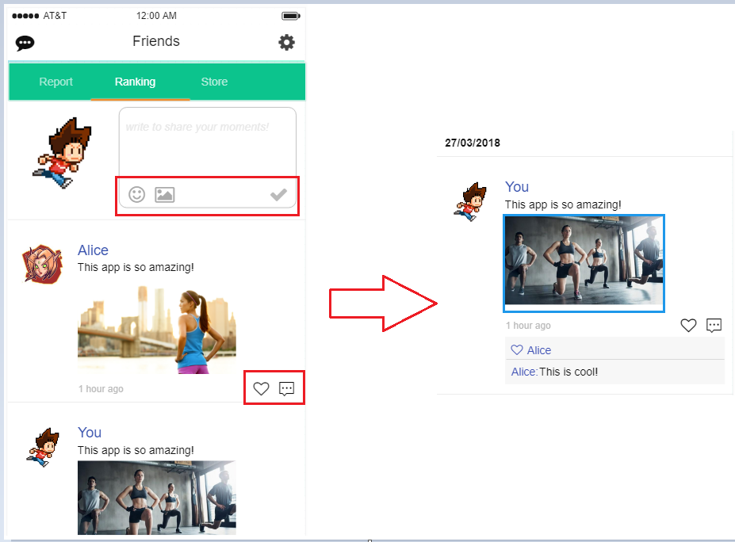

Interface for Android

**From Home to Setting screen:**

As mentioned before, the design of the application is quite consistent, thus the operation on each page could be same.

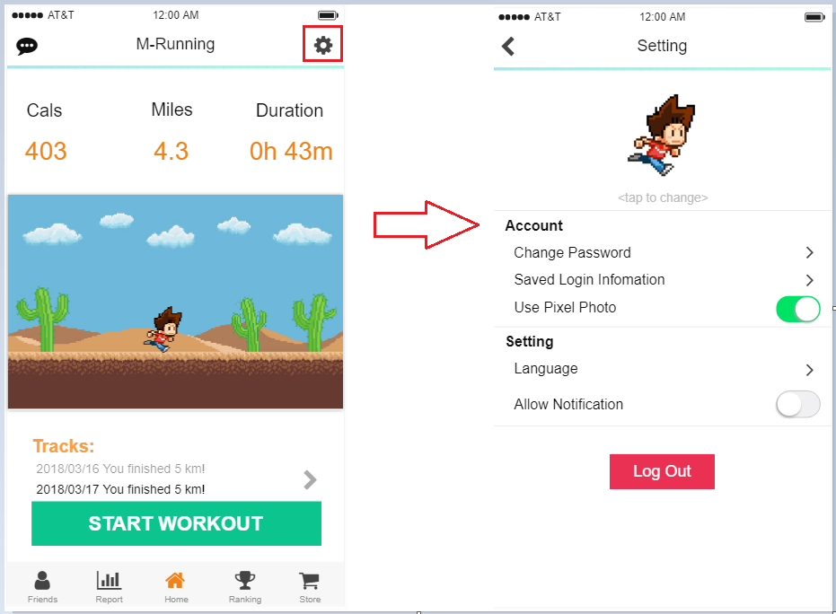

Interface for iOS

The difference between Android and iOS is the style of button in this page.

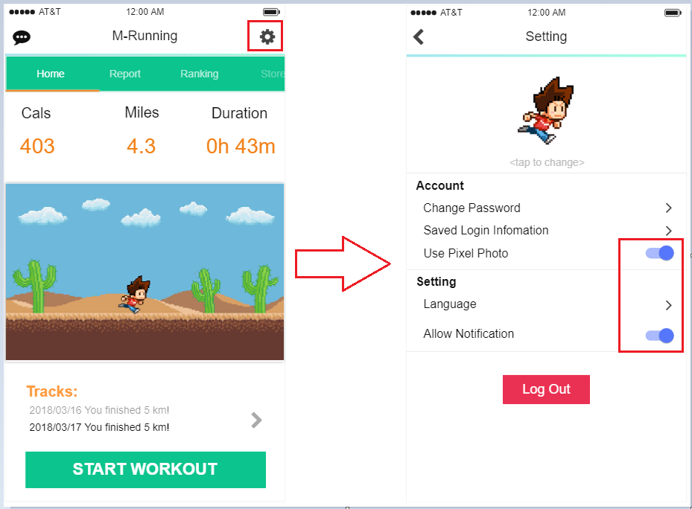

Interface for Android

**From Home to Me page:**

When users click the left corner button, they will see the Me page which locates users’ likes, friends and comments. The layout of the components provides a clear path which fits the guideline of ‘Always provide a clear path’.

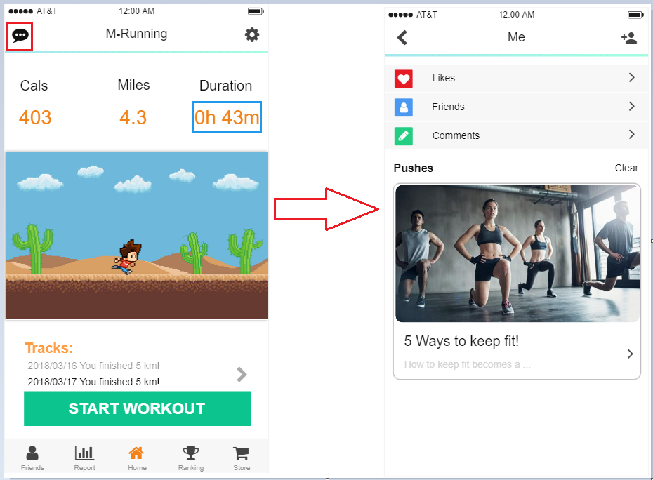

Interface for iOS

The interface for Android is quite the same.

**From Me to other functions inside:**

The navigation inside the Me page is obvious and clear by clicking buttons aside. The interfaces are same in Android and iOS.

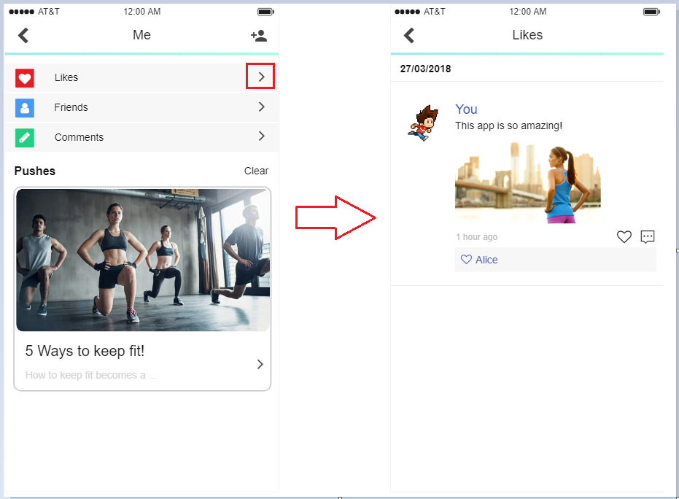

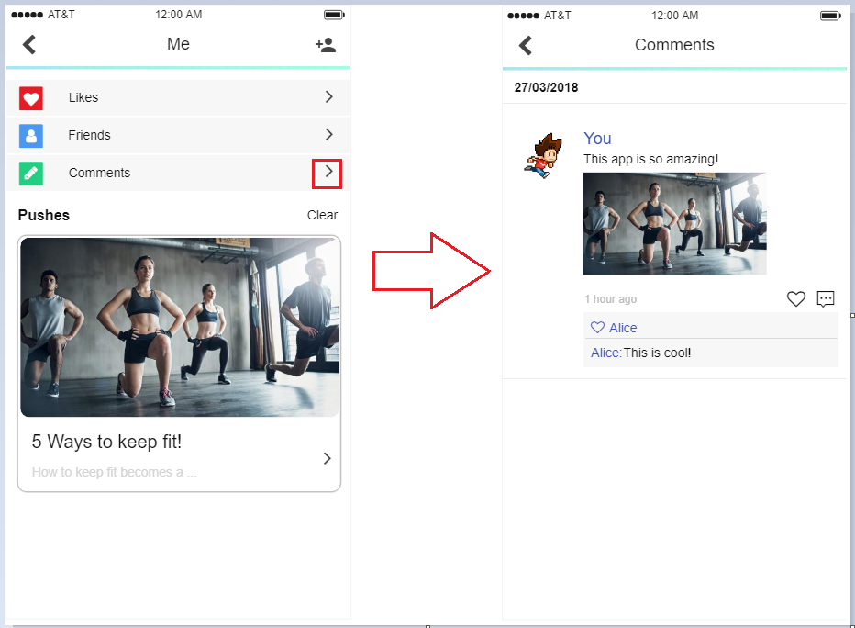

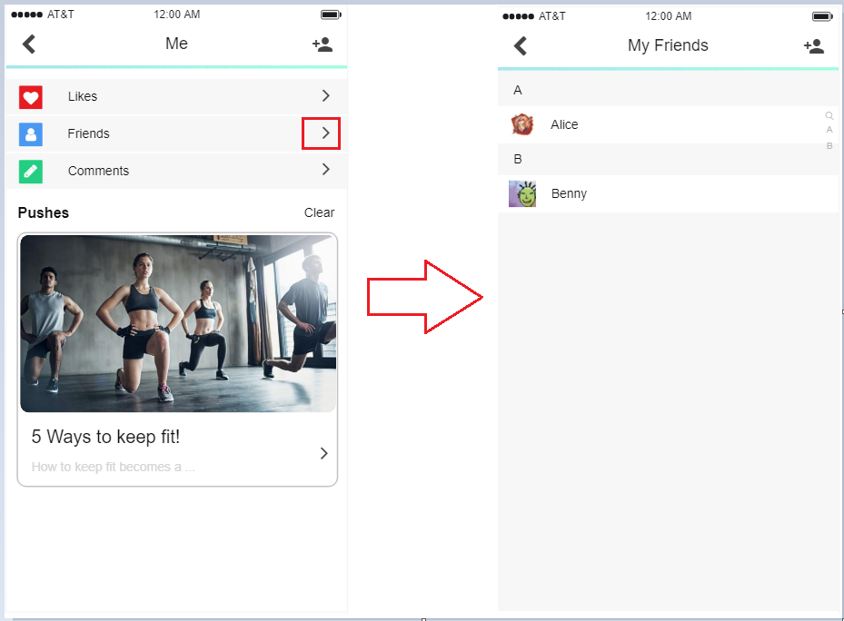

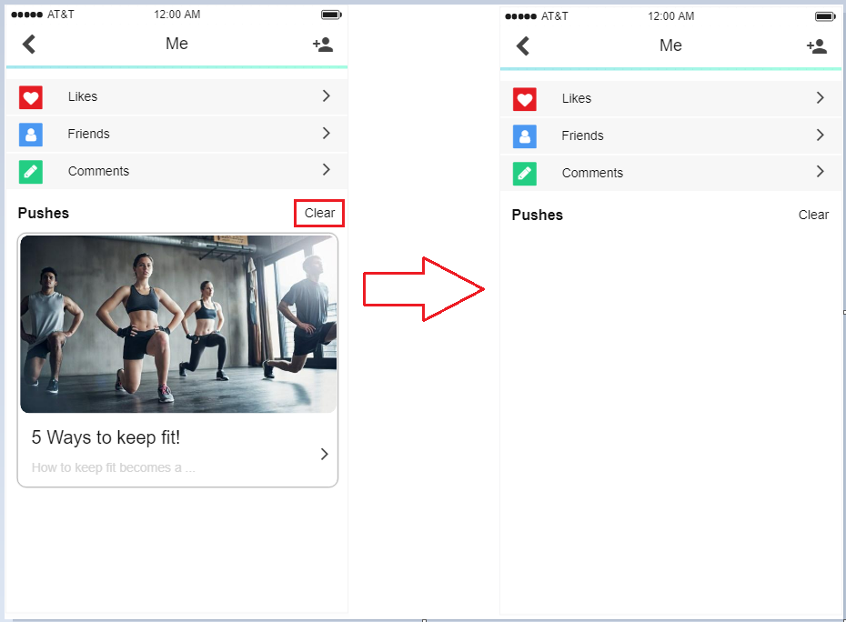

**From My Friends to Add Friends screen:**

Users can click the icon aside to add friends by typing some word in the search bar and the application would list all the likely users below. Users can then click the add button to send a request. The interfaces are the same in iOS and Android.

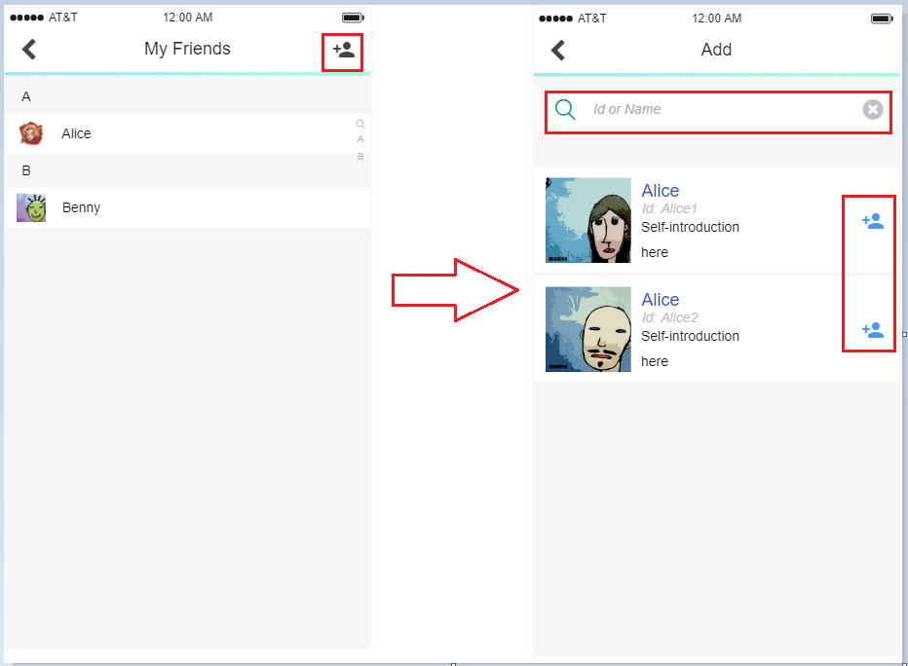

Interface in iOS

**From Home to Store page:**

The swap of categories is achieved by taping the tab bar. Inside the page, users can choose the grids below to preview the costumes and buy them by clicking them. The design of the pages strictly obeys the iOS design guideline of Consistency, which is ‘To user familiar standards, well-known icons, and uniform terminology.

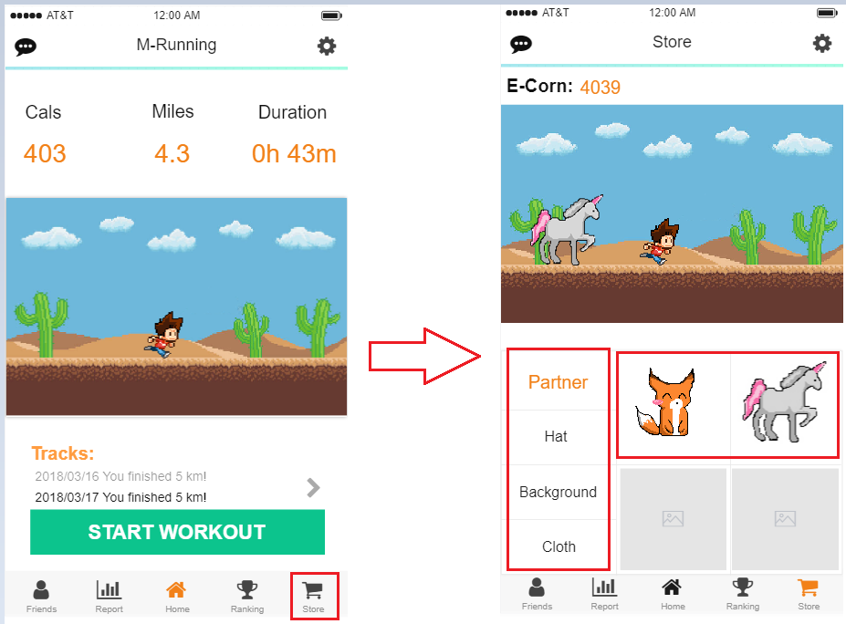

Interface for iOS

For android, the page changing can be achieved by swapping left or right or tab the tab menu at the top.

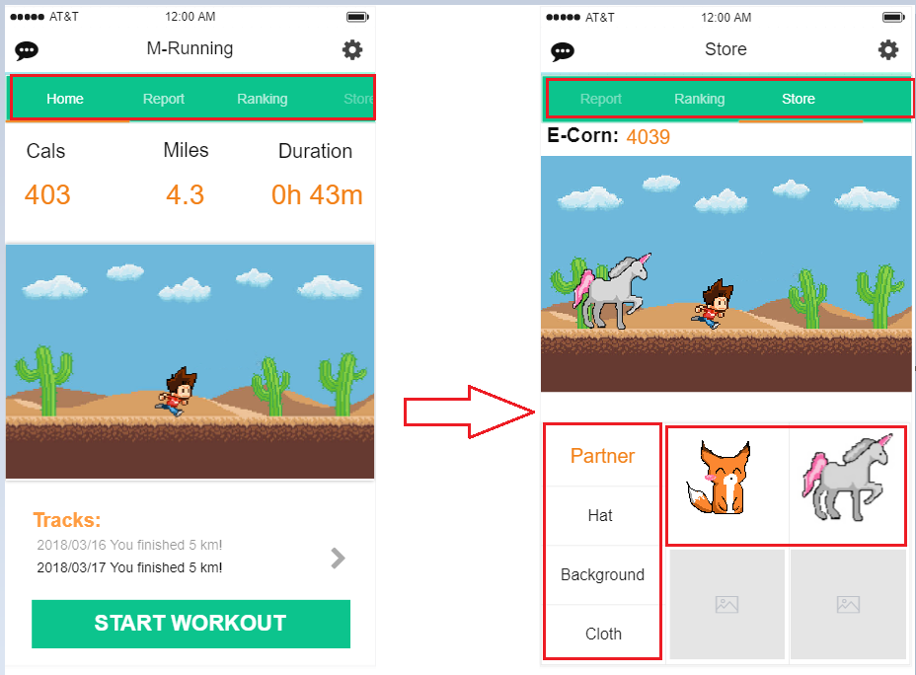

**From Home to Ranking page:**

The swap of categories is achieved by taping the tab bar. The design of the pages strictly obeys the iOS design guideline of Consistency, which is ‘To user familiar standards, well-known icons, and uniform terminology.

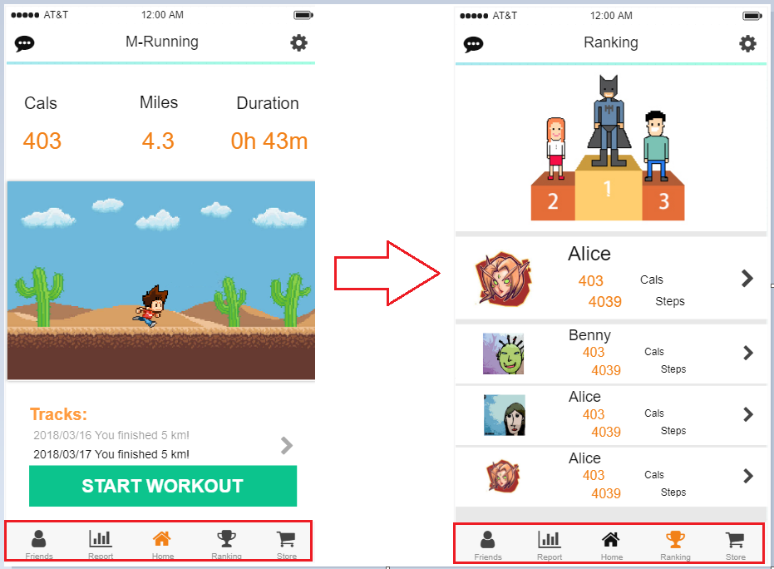

Interface for iOS

For android, the page changing can be achieved by swapping left or right or tab the tab menu at the top.

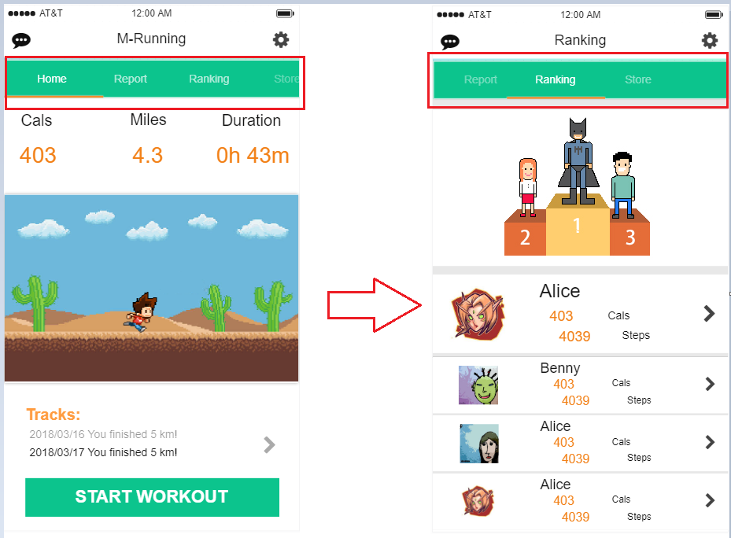

Interface for Android

**From pages to user Profile page:**

There are several ways to guide from other pages to user profile page. The interfaces are the same in Android and iOS. All the operations are using the direct manipulation which obeys the design guideline of ‘To use direct manipulation’.

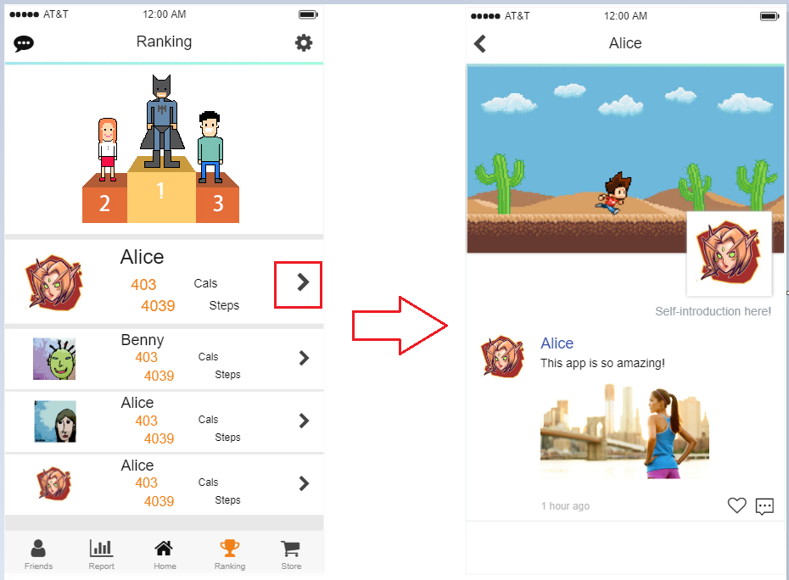

Interface for iOS

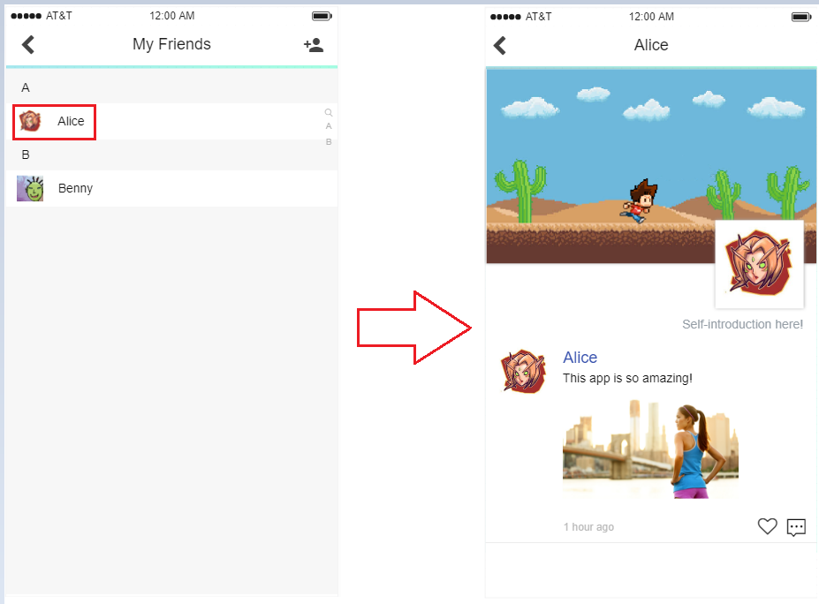

Interface for iOS

# 5. Scope and Limitations

Taking the teaching guideline as the reference, the lecture will cover almost all the technics required to build this app. If time permits, functions like chatting with friends, generate more professional diagrams, which will definitely increase the user experiences would be added into to application.

In terms of the rest implementable functions, if time allows, more costumes would be supplied to make the application more competitive. Because drawing the pictures could be a time-consuming task may require much more time.

# 6. Project Timeline

The sheet below are the estimated timeline, there would be some differences while implementing the timeline. Gantt chart is also inserted after to provide a clearer overview.





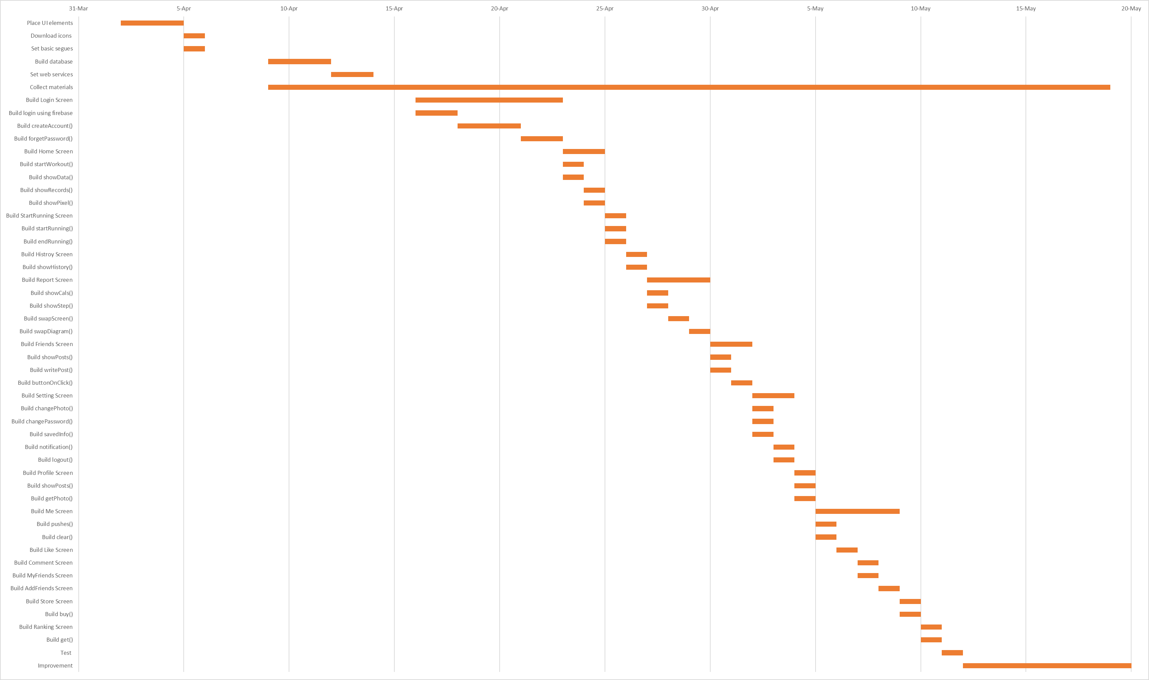

# 7. Competitive Analysis

There are many fitness applications available on the App Store, considering the rating and hotness, Nike+ RunClub is chosen as the comparison apps.

## 7.1 SWOT Analysis

**1. Strengths and Weakness**

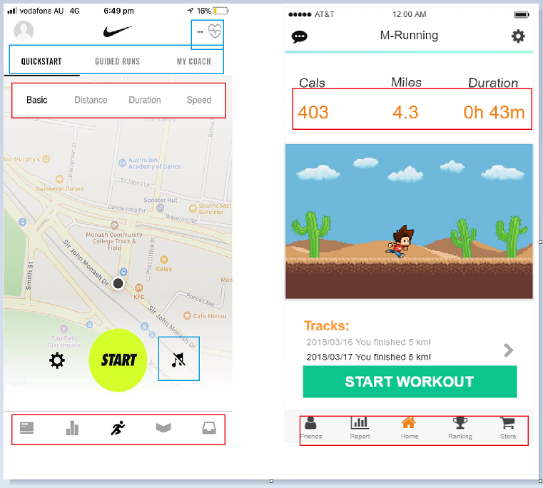

**Strengths:**

Nike+ provides more functions as circle in blue, which not supplied in M-Running such as detecting heart rate.

**Weakness:**

As circled in red in the picture, Nike+ needs to swap the segmented control to see other data while M-Running (my application) display all the necessary data directly on the screen. In addition, Nike+ uses a tab bar without signifiers, although some of the icons have obvious affordance, some of them are still confusing. The tab bar used in M-Running is clear in comparison.

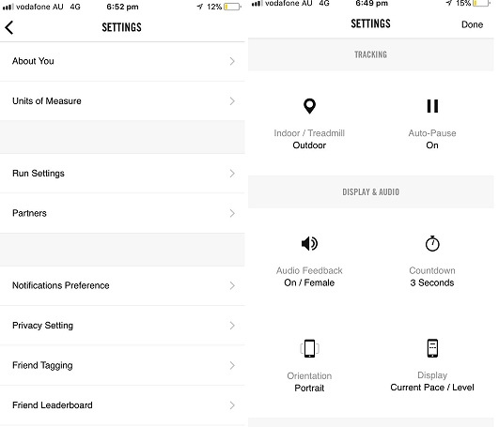

**Strengths:**

Nike+ provides more setting options to provide a more freedom customization experience with clear layouts.

**Weakness:**

As a running app on mobile, users may expect a simple using experience, more options mean more operations, which may to some content decrease the using experience.

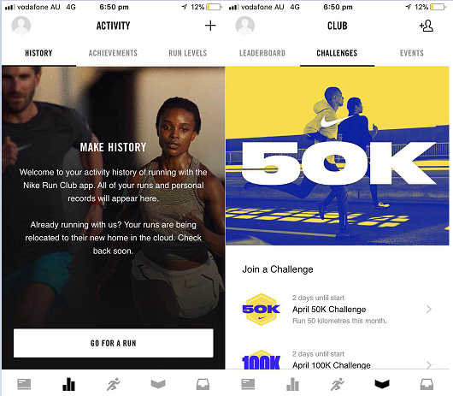

**Strengths:**

Nike is always a master at creating those inspiring pictures, along with the challenge system, the app would definitely be popular among those who are self-disciplined and enjoy running.

**Weakness:**

One main goal for developing an app is to attract more users, as analysed before, the challenge system could be an icing on the cake for those who are self-disciplined. However, how to attract those who are not self-disciplined or hesitating whether to use the app or not could be an issue for most applications. Thus, the dressing up system is designed to solve such a problem.

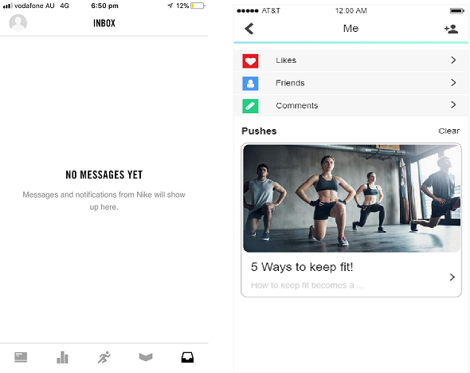

**Strengths:**

Nike+ puts the inbox on the tab bar which makes it easy to approach and also the design of the inbox is clean.

**Weakness:**

However, for some of the users, the inbox or message box would not be a main reason why they use this app. In another word, it may not be a frequently used function which should not be put in the tab bar. As for the M-Running, though it is not that direct to get to the message box, the main function would be workouts recording. Thus, users could focus on running rather than other things.

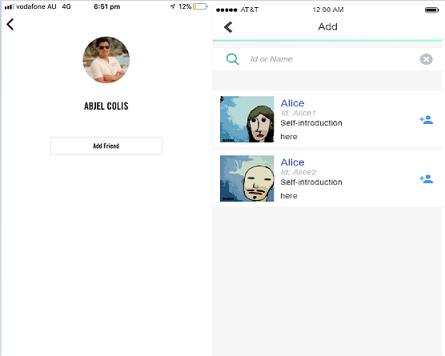

**Strengths:**

Nike+ puts few elements on the add friend screen which is consistent with its other screens.

**Weakness:**

However, more detailed information should be provided to users if they want to search for a friend. With displaying more detailed information, users can locate their target friend more quickly, which in some degree increases the user experience.

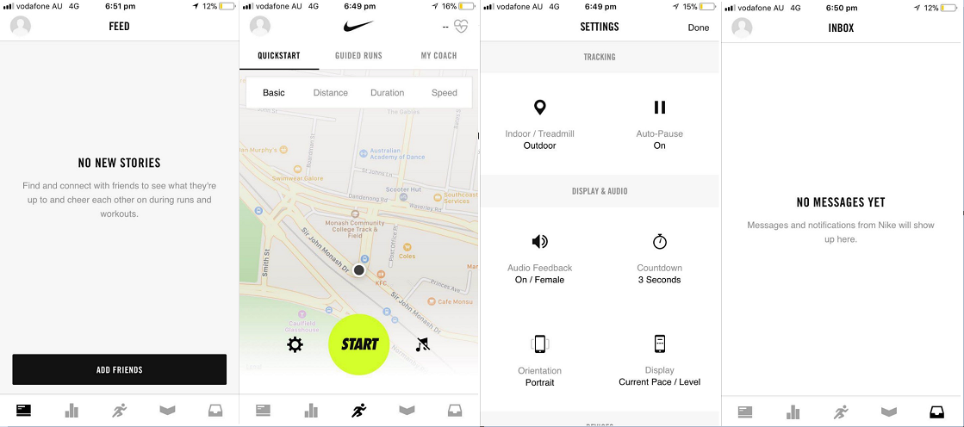

**Strengths:**

Nike+ utilizes a consistent layout and a same colour theme for all the screens, which to some content, strictly obeys the iOS design guideline of consistency. The layout provides users a clean visual feeling and it also reduces the eye strain.

**Weakness:**

However, after a long time using Nike+, it gives me a feeling of dull. While I was designing the screen of M-Running, I hope it could convey a feeling of healthy and energetic, thus I use green, orange and blue as the main colour tone to remind the users of life, energy and freedom and would help brighten the users’ mood.

**2. Opportunities**

After briefly using the Nike+, it is quite a good assistant to those sport lovers. They can join challenge groups to chat with those who also love doing workouts. Supporting by Nike’s professional sport equipment, the running experience on this app could be excellent. To enlarge this advantage, Nike+ should upload some tutorial videos to make this app a more professional sport app.

Inherently, only the satisfaction of basic functional needs will not help hold users, Nike+ continues keeping a geek style, which may be unpopular among those use these kinds of app few times a week. How to increase user sticky relationships should be an issue for nowadays application developers. Nike+ may not seen those users as their target stakeholders. M-Running creates a relax social intercourse atmosphere, not only the function allows them to share their moments with others, but also the dressing up system allow users to transfer their workouts into something visible, which could be a motivation to them.

**3. Threats**

So far, Nike+ is doing quite well among their competitors, however, with the development of technology and the improvement in aesthetic, more and more are catching up. Some of the app can even customize a series of courses according to users’ report. Nike should take advantage of its excellent resources and merge them into their application to provide a more professional using experience.

Another threat could be the weakness of its social system, users can only chat with each other, I didn’t find a way to share my moments or post some photos to my friends. Nowadays, more and more apps are integrating social systems into their system no matter what kind of applications they are. Anyone who use an application alone for a period of time will feel bored. Social system will create a stable user environment meanwhile boost user engagement.

## 7.2 App Store Analysis

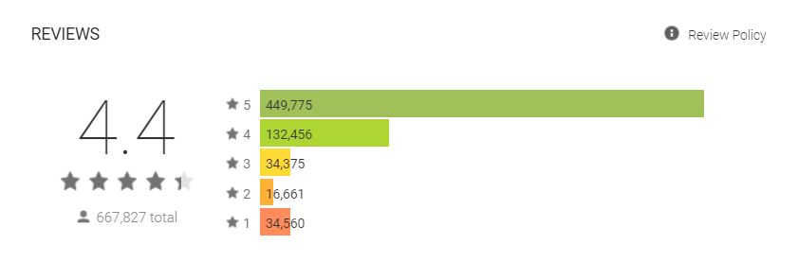

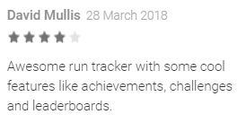 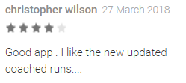

As we can see in the picture, the users’ ratings are quite high upon Nike+, and most of them are quite satisfied with the new function. From the reflection of the market, we can know that more advanced running models should be implemented.

However, as one of the user using this app, there is one problem which should be paid attention to, that is the optimization of the application. Nike+ uses real time map as its background, which means it requires some time to load the map after opening the app. Users can do nothing during the responding time, which could definitely reduce the user experience.

## 7.3 Target Audience ‘Needs’ Analysis

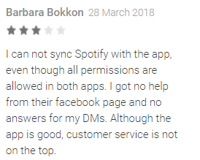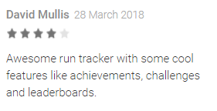

Users’ needs can be inferred from their reviews. From the above comments we can infer that the music function is necessary while using the running app. In terms of M-Running, if time permits, the music function should be implemented to make this app more competitive. From the second review, we can also infer that the challenge system, the achievements system, in another world, the system to encourage running is essential as well. Users need such encouraging system to help them keep doing workouts more frequently. Thus, in the later developing of M-Running, besides the E-store, more elements should be implemented to motivate users.

# 8. References

Jennifer Preece, Yvonne Rogers, Helen Sharp (2002). Interaction design: beyond human-computer interaction, John Wiley & Sons (Chapter 3)

Norman, N (1990) The design of everyday things. Double Day, Ch 1 and 2.

Shneiderman, Plasiant, Cohen, Jacobs (2014) Designing the User Interface: Strategies for Effective Human-Computer Interaction, Pearson (Chapter 4)